School History
Sacred Heart Canossian College was founded in 1860 by the Canossian Daughters of Charity. It was the first of nine Roman Catholic secondary schools founded by the Canossian Missions in Hong Kong and Macau.

The Canossian Daughters of Charity is a Roman Catholic religious order founded by Marchioness Magdalene, now St Magdalene of Canossa, from the House of Canossa in Tuscany, Italy.

Soon after the first Canossian Sisters arrived from Italy in 1860, they established a school for girls. This Italian Convent School, with 40 students being taught Chinese, English and Portuguese, was the beginning of the present Sacred Heart Canossian College. The first headmistress of the school was Sister Emily Bowring (1860 - 1870), daughter of the fourth governor of Hong Kong, Sir John Bowring.

From "Italian Convent School', it later changed its name to Sacred Heart School, after the Sacred Heart of Jesus. In 1960, the school was officially registered as Sacred Heart Canossian College.

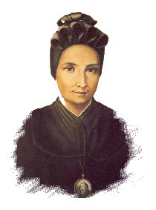
Vision & Mission
Our Foundress' Mission “Canossian educator should try to handle each one in the way she is made, valuing the benefit of education in the formation of the heart.” From St. Magdalene of Canossa

Our motto draws its inspiration from Jesus Christ who is THE WAY, THE TRUTH and THE LIFE. We take Christ as our model and seek to follow His footsteps.

To walk confidently and joyfully in the path of life, overcoming all difficulties with fortitude and prayer.

To be sincere in word and action, and to be open to truth and knowledge.

To live for others, be ready to share, serve and sacrifice for others.

We aim at providing an all-round education of Christian virtues and formation of the heart to empower our youngsters to be women of integrity and versatility with global awareness.

SHCC is committed to the principle that all students can develop to their full capacity. SHCC adopts a liberal approach to learning and teaching which encourages self-motivation, understanding, creativity and character development: an approach which stresses not only getting a good grade per se but most importantly the development of the students' knowledge, skills and attitude in the spiritual, academic, social, artistic and physical aspects.

